Grand Challenge: Mapping the Human Immune System
Tue, 10/04/2016 - 8:54amby University of Arizona
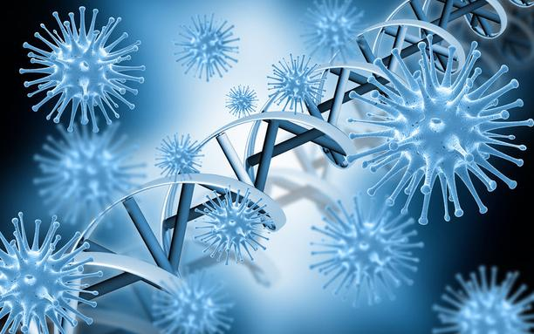
University of Arizona research assistant professor and immunologist Adam Buntzman used CyVerse data-sharing and analysis capabilities to lead the first team to comprehensively map the human adaptive immune system.
Knowing the full potential for our immune systems to protect us from harmful pathogens brings us one huge step closer to finding cures for illnesses such as cancer, infections, autoimmune diabetes and asthma, as well as developing improved diagnostic tests and immune therapies.
"Understanding adaptive immunity is one of the grand challenges in science," said Yves Lussier, associate vice president for UA Health Sciences and executive director of the UA Center for Biomedical Informatics and Biostatics. "The unique genetics and massive diversity that occur exclusively in cells of the adaptive immune system has posed a dire need for computer tools created specifically to analyze adaptive immune receptors."
Now Buntzman and his collaborators have combined the expertise of immunologists, mathematicians and computer scientists to develop these much-needed computational tools.
"If we were on a treasure hunt, where the cure to many illnesses is the buried treasure, then we've just drawn the first map of Treasure Island," said Buntzman, an investigator in the lab of Monica Kraft, a physician-scientist specializing in research of dysfunctional autoimmune response in asthma and chair of the UA Department of Medicine.
More Complex Than the Human Genome
The adaptive immune system is perhaps the most mysterious — and certainly one of the most vital — systems of the human body, protecting us from everything from common cold germs to serious infections. Cells within the human adaptive immune system produce antibodies and T-cell receptors that identify and remove harmful foreign substances from the body.
Unfortunately, the immune system can become a powerful enemy when it misidentifies a part of the body as pathogenic, leading to autoimmune diseases, or when it overreacts to foreign materials such as pollen, resulting in allergies such as asthma.
The immune system is considered to be "adaptive" because it can respond to our unique environments. Once it has overcome a particular pathogen, the immune system will "remember" and quickly destroy that pathogen if it ever enters our bodies again, thus giving us immunity.
Adaptive immune systems also vary from one person to the next, providing immunity depending upon what microbes an individual has been exposed to throughout their lifetime.
"Humans have about 25,000 genes in our genome, but there are millions of harmful microbes, which begs the question: How does such a small number of genes code for all of the immune receptors needed to recognize the enormous array of microbes that can hurt us?" Buntzman said.
It turns out that immune receptor genes do not code for immune receptors; rather, broken gene fragments combine in novel ways to produce new code.
Every time a new antibody or T-cell receptor is created, the adaptive immune system "shuffles the deck" of gene fragments, blending together the broken pieces through a process called VDJ Recombination.
"These gene fragments are then modified by enzymes, creating a dizzying array of variation," Buntzman said.
The possible variation of immune receptors far exceeds the number of genes in our genome, at roughly 10 million times more than the number of stars in the Milky Way galaxy, he noted. That's also about 100-fold the number of ants on Earth.
And therein lies the complication.
"How do we study this much diversity? How do we find which receptors cause autoimmune disorders, and which receptors protect us from influenza?" Buntzman said.
Genome sequencing instruments have addressed the problem yet remain incapable of handling the enormity of data. Until now.
How to Count Countless Possibilities
Just as genomics involves sequencing whole genomes, the field of immunomics involves mapping sequences of immune receptors — a mathematical challenge given that the human adaptive immune system swamps the diversity of most genomics studies.
Buntzman calculated that using traditional computational methods to generate a complete genetic map of the immunome — all possible receptors the immune system might generate — would take roughly 106 years.
"Waiting that long is clearly impractical," he said, "but this is where CyVerse comes in."
Headquartered at the UA's BIO5 Institute, CyVerse is a National Science Foundation-funded project to provide computational infrastructure for big-data problems in the life sciences.
Buntzman began working with CyVerse collaborator Ali Akoglu of the UA College of Engineering to develop computational tools to map the immunome using high-performance computing, or HPC, techniques.
With access to HPC technology and support through CyVerse, Buntzman, Akoglu and Akoglu's graduate student Gregory Striemer developed a program to run the analysis in under 17 days on a computer chip housed inside a simple laptop.
"My role was to restructure the algorithm to accelerate the results," Akoglu said. "This was the first study to generate and process terabytes of data exhaustively, going through all possible combinations of sequences, and in a relatively short amount of time. And CyVerse was the catalyzer that brought us together."
Armed with the power of computation, Buntzman and his colleagues have developed a software tool capable of comprehensively mapping the adaptive immune system without limitation, and a computer program that is a community-accessible utility to database these complex immunome datasets, as described at the 2016 conference of the American Association of Immunologists and in an upcoming publication to be released in the journal BMC Bioinformatics.
In addition, Buntzman's group has developed another computer program to run a novel algorithm called iWAS, or immunome-Wide Association Study, that can mine the immunome for patterns of immune receptors responsible for protecting us from specific diseases or causing autoimmune disorders.
Understanding the role of individual immune receptors could pave the way to developing advanced therapies, potentially revolutionizing the field of adaptive immunity.
"This work will aid in the study of cancer, autoimmunity, transplantation and vaccination, and assist in developing new precision medical diagnostics and patient-centered immunotherapies, as well as identify biomarkers for inflammatory diseases," Lussier said.
Collaboration was key, Buntzman added.
"By working across disciplines as immunologists, mathematicians and computer scientists," he said, "we were able to tackle a problem that was untenable to any discipline alone. We've created an analytical infrastructure with CyVerse that allows for all the data to be stored and analyzed by researchers everywhere."

